# **ENG 101: foundations of writing & rhetoric Minnesota State University, Mankato | Fall 2021 Monday & wednesday 2:00 - 3:40 p.m. | Armstrong hall 203**

# Course Description

First-Year Writing (ENG 101) or "Foundations of Writing & Rhetoric" is a process writing course. Students in this course approach writing as a subject of study by investigating how writing works across a variety of contexts. Most Minnesota State Mankato students take this course during their first two years of college. As a matter of best practice, we strongly encourage students to take ENG 101 during their first two semesters.

# Course Learning Objectives

In this course, we will investigate how writing works by:

1. Increasing genre awareness, rhetorical knowledge, and use of multimodalities
2. Exploring language variation and multiliteracies by context
3. Developing information literacy through primary and secondary research
4. Reflecting on writing processes and labor
5. Collaborating to create and revise texts

# Course Materials

You do not need to purchase a textbook for this course. I will supply all of your required readings via our course D2L site. I will also use D2L to communicate updates and messages to the class. It is important that you have word processing software such as Microsoft Word, reliable internet, D2L, MAVmail, Zoom, and Google Docs in order to perform effectively in this class. Contact me immediately if you have any concerns regarding your technology resources.

# Instructor Information

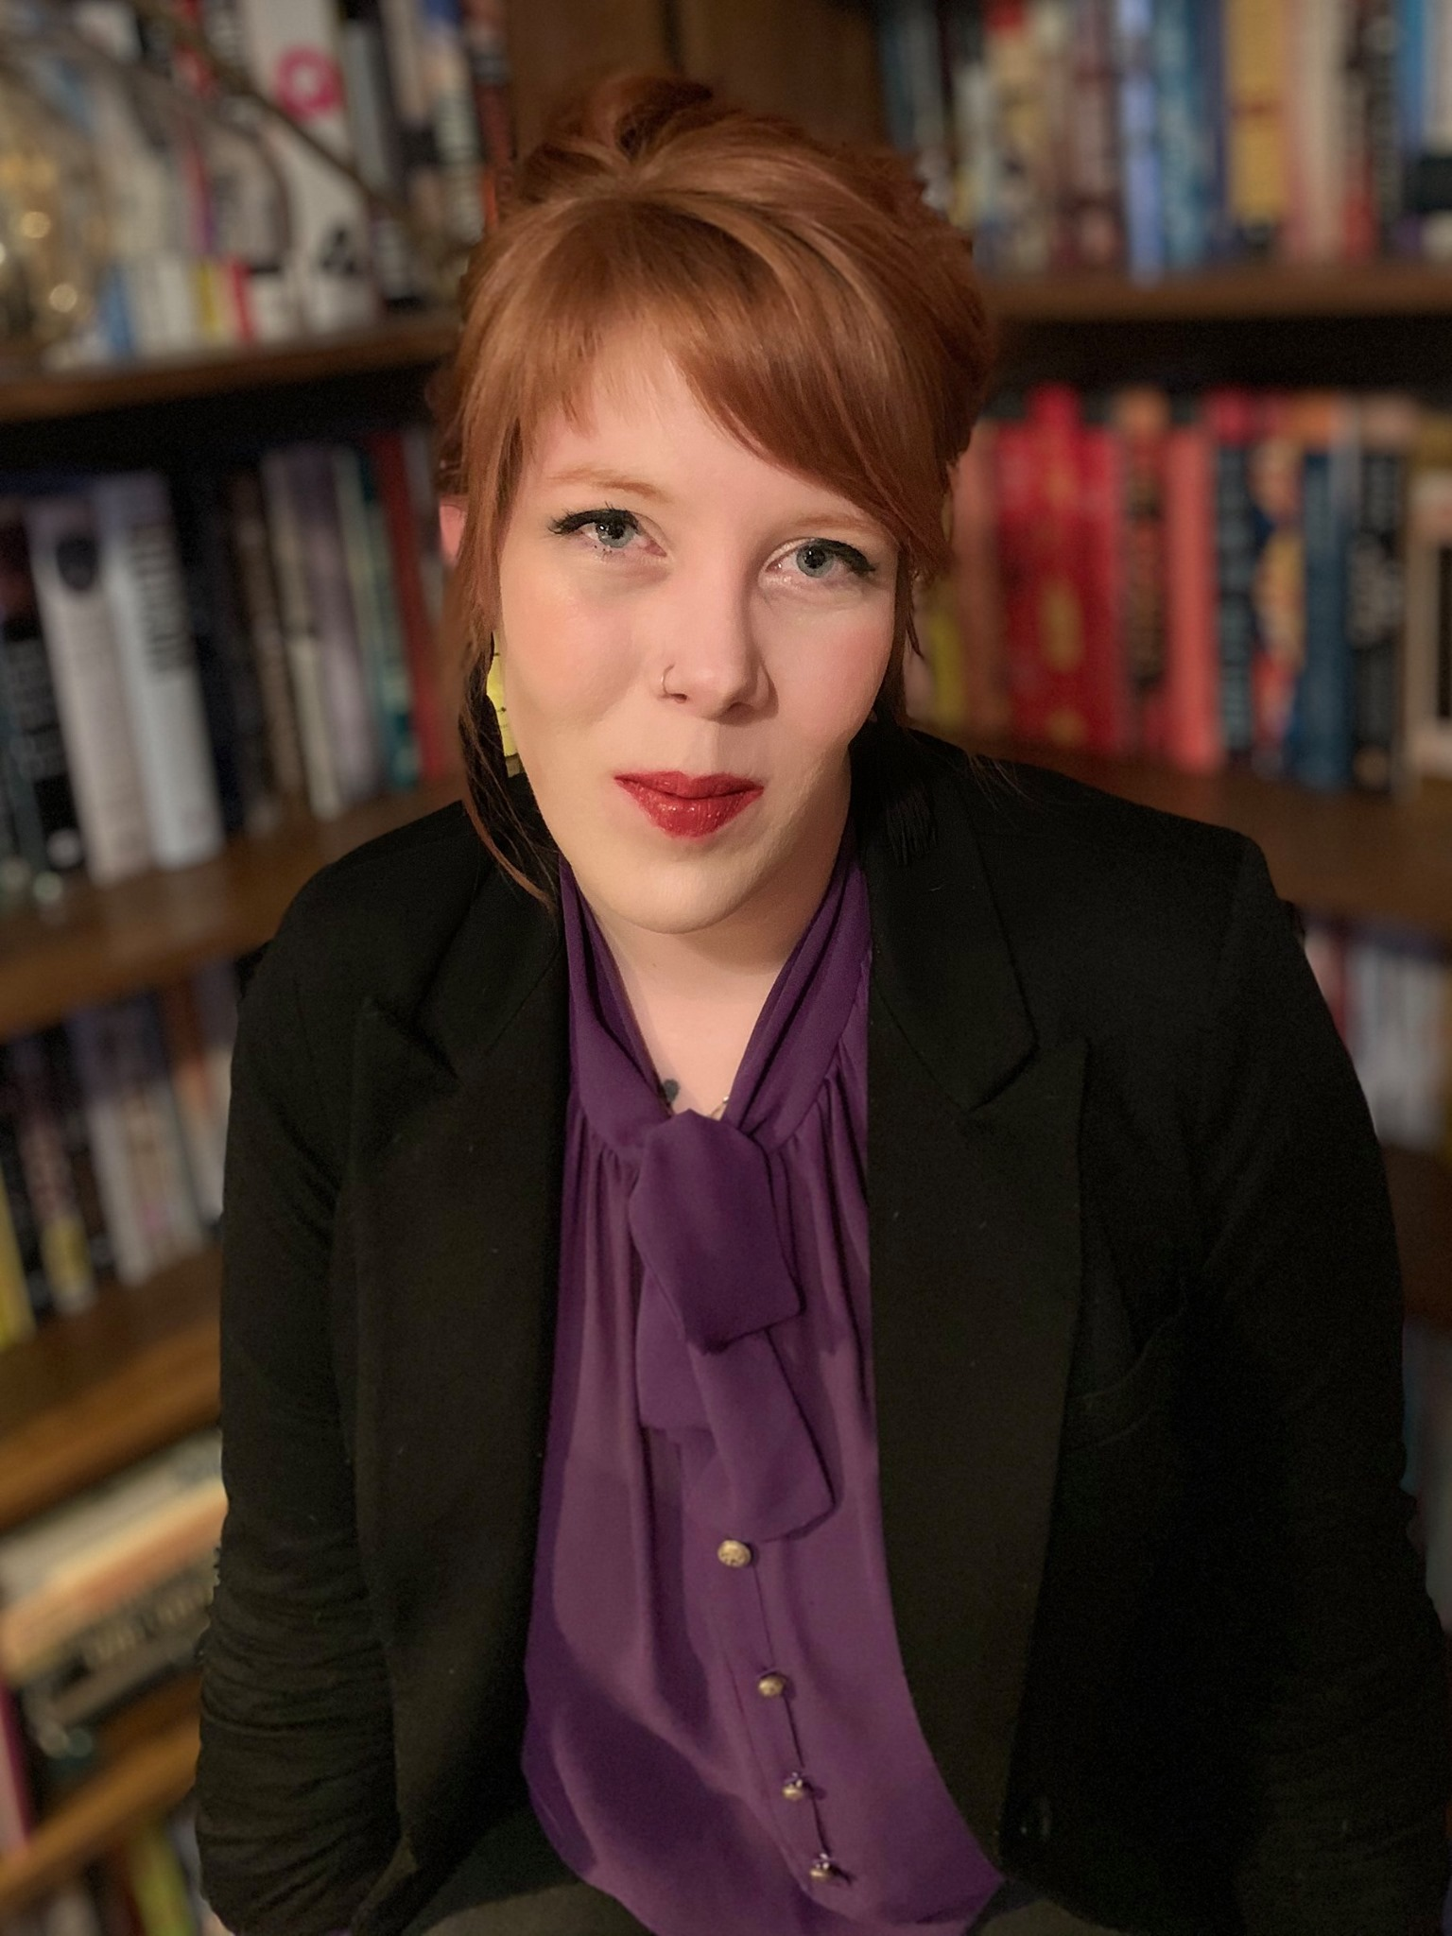**Holly Dodge** – call me Holly  
she/her/hers  
Email: [holly.dodge@mnsu.edu](mailto:holly.dodge@mnsu.edu)  
Call or Text: 507-200-2816  
Office Hours: AH 210 Thursdays 12:00 p.m. – 2:00 p.m.   
Office Hours Zoom Link: https://minnstate.zoom.us/j/9993311374

**About Me**I received my bachelor’s in creative writing from MSU and I am currently   
earning my master’s in creative writing with a focus in poetry. Outside of   
school, I stay busy as a mother of two kiddos, three cats, and a dog. I also   
enjoy painting, reading, music, camping, and volunteering in the community.

# Class Format

**Our class meets in-person on Mondays and Wednesdays each week from 2:00 - 3:40 p.m. in AH 203.**

The nature of a writing course makes it difficult to catch up if you fall behind. I highly recommend that you do not wait until the night before to complete your work. Be diligent in setting realistic work times for you to complete your assignments. These writing assignments require a lot of time. To keep you on track, I have entered due dates for all assignments via our class D2L page. You can sign up for D2L notifications to remind you of upcoming deadlines.

# MavPASS (Peer-Facilitated Academic Support System)

This semester, we are offering additional support to help students to succeed in this course. Students who have taken this class in a previous semester have been hired as MavPASS Leaders to sit in on the course with you, facilitate study sessions outside of class, and hold office hours. The MavPASS Leader(s) in your course will share with you the time and location of the study sessions and their office hours; you can also find the schedule at www.mnsu.edu/mavpass. For additional information, please email us at [mavpass@mnsu.edu](mailto:mavpass@mnsu.edu).

# Participation Policy

Your participation helps create a collaborative and engaging classroom experience for all. Our class will exhibit patience, flexibility, and good humor and will never demean, judge, or ostracize one another. Classroom participation will be factored into your final grade. Please be generous with your input!

# Course Grades

Your final grade will be determined by the amount of effort and labor you put into the class, as detailed in our course Grading Contract. The contract is available as a separate document on D2L. Once you have read the grading contract and thought about how much effort you are willing to put into the course, I will ask you to sign a contract online. If for any reason you do not accomplish the expected amount of labor for the grade you want in the course, at the end of the semester you will earn the grade that most closely aligns with the amount of work you completed. I encourage you to check your D2L gradebook often and reach out to me whenever you have questions or concerns about your grade.

# Policies

The course Grading Contract establishes expectations for your labor in the class. Building on those expectations, I have a few guidelines for how we can best interact with each other in our classroom.

* We will respect each other, including others’ opinions. This does not mean we’re not invited to challenge each other, but rather that we will do so without demeaning each other’s identities, character, or writing.
* We will bring our best effort to this class each day, recognizing that some days we have more to give than others.
* We will take care of each other by asking questions, participating in discussions and activities when called for, and collaborating effectively when asked.

# Course Content

#### formal WRITING PROJECTS

Throughout the semester you will complete four formal writing projects designed to help you learn and grow as writer. There will not be any exams in this course.

**Project 1: Literacy Narrative- Due September 22**

You will describe an event from your life that represents who you are as a reader, writer, and/or language-user and discuss how that event influences your learning goals for this class.

**Project 2: Rhetorical Analysis- Due October 20**

You will critically analyze a text utilizing the elements of rhetoric.

**Project 3: Field Research Project- Due November 17**

You will conduct a study of a community or group in order to learn more about how they use language and literacy.

**Project 4: Final ePortfolio- Due December 8**

You will revise and assemble work from this course, including a brief *Theory of Writing* project, in order to represent what you learned and who you are as a writer.

#### Informal Assignments

You will also be asked to complete various informal assignments designed to help you in the writing of your formal writing projects. Most often these will come in the form of whole-class or small-group discussions on D2L, readings and responses, but there will also be the occasional solo activity. See the course Grading Contract for information on how informal assignments affect your grade.

#### Reading & Writing Journal

You will also keep a Reading & Writing Journal for the class. You will use this journal to take notes on the assigned readings and respond to reflective prompts about your writing. Your journal is meant to be a space for you to keep track of your own learning—while I’ll check it occasionally, the work here is for you, not me. See the course Grading Contract for how the Reading & Writing Journal affects your grade.

#### Linguistic Diversity

Diverse languages and dialects are welcome in this classroom. As we communicate with one another, keep in mind that the reader/listener should work as hard as the writer/speaker in the communication process. This means that we will listen patiently, work to understand one another, seek out clarification when necessary and avoid finishing each other's sentences or correcting grammatical errors unless invited to do so.[1]

#### Academic Honesty

I expect that the work you submit will always be honest and responsible. Plagiarism, which is defined as submitting an academic assignment containing someone else’s critical ideas or direct words without proper attribution, will not be tolerated. View the university’s full policy on Academic Honesty, including reporting procedures and possible repercussions, here: <https://www.mnsu.edu/policies/approved/academichonesty.pdf>.

# Resources

I’ve linked several resources below, and more on D2L, to aid in your success at MNSU. Please make use of these resources, and if you need something I haven’t shared, let me know. **You matter and I am here to support you.**

**Accessibility Resources**

MSU, Mankato provides students with disabilities reasonable accommodation to participate in educational programs, activities or services. Students with disabilities requiring accommodation to participate in class activities or meet course requirements should first register with Accessibility Resources, located in 0132 Memorial Library, telephone 389-2825, TDD 711 and then contact me as soon as possible.

**The Counseling Center**

The Counseling Center provides a range of help and services, from individual and group counseling to referrals. Services are free, comfortable, and confidential; the Counseling Center is here to help students navigate any difficulties going on personally, socially, or in school. It doesn’t have to be crisis—no problem is too small. The Counseling Center is offering remote services. For more information, see http://www.mnsu.edu/counseling/all2020.html

**The Writing Center**

The Center for Academic Success offers free tutoring in writing for all students enrolled at MSU, Mankato. Students can work one-on-one with a trained consultant to receive objective, constructive feedback on their academic writing assignments. For more information, visit [www.mnsu.edu/success](http://www.mnsu.edu/success).

**Student Technology Tools and Resources for Online Learning**

MNSU offers software, applications and digital tools for all students to ensure you have everything you need for successful learning in an online environment. Review all the resources available here: <https://mankato.mnsu.edu/academics/online-and-off-campus-programs/online-education/student-technology-tools-and-resources-for-online-learning/>

If you have any challenges with technology or internet, please contact me ASAP.

**Basic Needs**

If you are having trouble affording enough to eat or don’t have safe and reliable places to sleep, there are resources available to assist students. I have listed a few additional resources on our class D2L page under ‘Student Resources’. If you need any additional assistance or resources, please do not hesitate to reach out to me.

1. This statement comes from Catherine Savini’s “[10 Ways to Tackle Linguistic Bias in Our Classrooms](https://www.insidehighered.com/advice/2021/01/27/how-professors-can-and-should-combat-linguistic-prejudice-their-classes-opinion).”